## Bricks Using Clay Mixed with Powder and Ashes from Lignocellulosic Biomass

A Major Project Report Submitted

in Partial fulfillment of the requirement for the degree of

BACHELOR OF TECHNOLOGY

## IN

## CIVIL ENGINEERING

## MAJOR PROJECT SUBMITTED BY

K. ALTHAF ANSAR(R170402**)**

Under the esteemed guidance of

**Mr.G. VENKATESH** sir

Assistant Professor

Civil Engineering Department



RAJIV GANDHI UNIVERSITY OF KNOWLEDGE TECHNOLOGIES

R.K.VALLEY -A.P-516330

FEBRUARY-2023

## CERTIFICATE

This Is to Certify That the Project Report Entitled “Bricks Using Clay Mixed with Powder and Ashes from Lignocellulosic Biomass “Submitted By K. Althaf Ansar (R170402) , Is Here By Approved for Submission At Civil Engineering Department, Rajiv Gandhi University of Knowledge Technologies, R.K. Valley.

**Head of the Department Project Guide**

Mr. Ramesh Kailas D Mr.G. Venkatesh

Assistant Professor Assistant Professor

**DECLARATION**

We certify that,

The work contained in this report has been done by us under the Guidance of Mr.G.Venkatesh sir . The work has not been submitted to any other institute for any degree or diploma. I have confirmed to the norms and guidelines give in the Ethical Code of Conduct of the Institute. Whenever I have used material (data, theoretical analysis, figure and text) from other sources, we have given due credit to them by citing them in the text of the report and giving their details in the references. Further, we taken permission from the copyright owners of the sources, whenever necessary.

Date: 8th February 2023

Place: IIIT RGUKT RKVALLEY

**ACKNOWLEDGMENTS**

I would like to thank respected **MR.G.VENKATESH,** Department of Civil Engineering, Rajiv Gandhi University of Knowledge Technologies, RK Valley for giving us such a wonderful opportunity to expand our knowledge for our own branch and giving us the opportunity to work under him. It helped us a lot to realize of what we study for.

I wish to express deep sense of gratitude to our guide **MR.G.VENKATESH** for his guidance and useful suggestions, which helped us in completing the project work on time.

I wish to express thanks to a great people who helped and supported us during this project.

## CONTENTS

Abstract

Introduction

Literature Review

Experimental Studies

Methodology

Analysis and Findings

Advantages and Drawbacks

Conclusion

References

## ABSTRACT

The production of fired or stabilized bricks from lignocellulosic biomass ash is thoroughly examined in this project. Bricks are typically made through the high-temperature firing process or by stabilizing the mixture with binders such as lime and cement. These bricks have a large carbon footprint and high levels of grey energy. In many parts of the world, the excessive use of clay as a natural raw material for the production of conventional bricks will lead to its scarcity. The mixing of clay with lignocellulosic ash during brick manufacturing leads to a better and more reliable solution that conserves scarce natural resources and reduces the impact of environmental pollution. This study aims to review the state of the art in the production of bricks based on lignocellulosic ashes and their physical, thermal, and mechanical properties. The most recent data in the literature related to the manufacture of lignocellulosic ash-based bricks either by firing, cementing or geopolymerization, the design of mixtures, as well as the identification of the main factors influencing the performance and durability of these bricks are presented and discussed. Despite extensive research, there is still very little commercial use of waste bricks in general and lignocellulosic biomass ash in particular. Various toxicity issues of lignocellulosic ash used in brick production limit their use on an industrial scale due to a lack of appropriate standards. In order to achieve practical production of bricks from lignocellulosic ash, research is still needed on standardizing and sustaining biomass ash recycling.

.

**1.INTRODUCTION**

**1.1 Scope and Objectives**

Clay brick is one of the most basic building materials used in the construction field worldwide. Brick factories are very energy-intensive businesses. In 1998, a brick factory with a daily production capacity of 400 tons used up to 5 GWh of electricity and 56 million thermies (1 thermie = 4,185,500 joules) of natural gas annually, for total annual energy consumption of 70 GW. Furthermore, this energy consumption accounts for approximately 50% of the total cost of production. As a result, the consequences are significant for brick manufacturers, who would have to modify their processes. Hence, the reduction of energy consumption and emissions in the manufacture of bricks, especially during the drying and firing stages, the reduction of production costs, and the preservation of natural resources are nowadays the main challenges of the ceramic industry.

In front of the requirements of comfort and the increase of the real estate parks, one observes that the building and public works sector is currently in whole proliferation. This yields a huge growth in the consumption of natural resources and negatively affects our environment. Indeed, the materials which are now used in construction are energy consuming, not ecological since they are made of minerals and carbon-based materials that are not biodegradable.

That is why the investigation of alternative bricks using clay and biomass would be a promising path for reducing pollution impact on the environment, improving the characteristics of the brick, and preserving the natural clay resources.

The primary goal of the current project is the valorization of lignocellulosic biomass ash when used as a substitute material for the production of fired and unfired bricks. A significant amount of this waste is produced annually by the burning of various types and forms of solid biofuels that are fed into boilers, stoves, and furnaces. Incorporating ash into ceramic production would be a promising way to lessen the dangers associated with this kind of waste’s impact on the environment, ease the strain on clay resources, and cut down on energy use and carbon dioxide emissions.

**1.2 Lignocellulosic Biomass and Its Composition**

According to the European Directive 2003/30/EC, biomass is all types of biodegradable products/by-products from forestry residues, woody processing industries, agriculture (animal and plant residues) as well as municipal and industrial waste (food industries), allowed for energy use in accordance with environmental protection regulations. Hence, biomass can be classified into four types: Forestry waste, Agricultural waste, Aquatic residues, and other origins. The waste of agricultural origin and forestry are classified as lignocellulosic biomasses. Lignocellulosic biomass is a fibrillar biological structure composed of cellulose, hemicellulose, and lignin as it is illustrated in Figure 1, in relatively small proportions of non-nitrogenous extractives, crude proteinaceous material, lipid, and mineral matter. Plant species, age, and organs determine the proportions of these constituents.

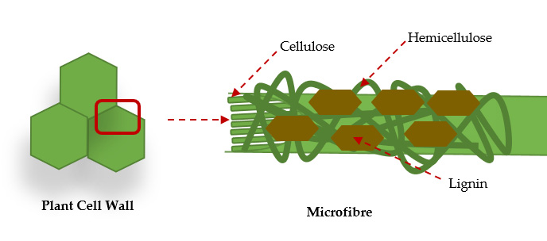

**Figure 1.** The main structure of lignocellulosic biomass.

The world’s production of lignocellulosic biomass is estimated at more than 220 billion tons per year In order to valorize this type of waste and preserve the environment, biomass can be used in animal feed, soil fertilization, as well as biofuel. Indeed, lignocellulosic biomass has a significant calorific value thanks to its chemical composition rich in organic matter and combustible carbon, which favors its energy

valorization as biofuels. Currently, biomass contributes between 8% and 15% of the

world’s energy supply in the form of heat and/or electricity and transport fuels. Therefore, around 476 million tons of biomass ash are generated worldwide each year through the biomass burned is estimated at 7 billion tons with an average ash yield of 6.8% on a dry basis. These ashes are classified as hazardous materials because they contain high percentages of heavy metals. It has been proved that the addition of such by-products (olive waste, rice husk, palm waste, paper pulp residues, Typha Australis, sunflower seed cake, wheat, and sawdust straw . constituted an innovative and effective way of generating more pores in the fired bricks.

**1.3 Clay and Its Properties**

Clay is a natural mineral product, abundant and of small granulometry that, in the presence of water, forms a plastic paste that hardens after firing. These properties have attracted greater attention of researchers as a primary source in the ceramic industry and more specifically in the manufacture of bricks. Moreover, different factors can affect the quality, strength, and durability of these produced bricks, including particle size, Atterberg limits, calcium carbonate content, and chemical composition.

**1.3.1 Particle Size Analysis**

The clay granulometry gives orientations on the quality of the elaborated bricks. Indeed, to obtain good quality bricks, the soil must not be too clayey so that the clay fraction of the soil (<2 µm) must be higher than 5% and lower than 30% playing the role of a binder and the coarse grains (silt and sand) must have an average diameter lower than 5 mm giving the stability of skeleton. The granulometry of the clay was crucial since it allows us to judge useful or not the use of the sand as a degreaser, and it provides also information on the plasticity of produced samples.

**1.3.2 Atterberg Limits**

The Atterberg limits are geotechnical parameters intended to identify soil and determine its consistency limits. They allow an approximate value on the quantity of water necessary during the shaping of bricks. In addition, they provide essential information on the mechanics of the soil via the determination of its plasticity index. For instance, it is recommended that the plasticity index of the soil should be between 5% and 15% for bricks because the highly plastic nature causes the excessive use of water.

**1.3.3 Chemical Composition**

Physical and mechanical properties of bricks are strongly influenced by the composition of the clay. Silica (SiO2), the main component of clay, exhibits the highest content compared to other elements which allows it to play an important role during the skeleton brick elaboration. The second main component of the clay is alumina (Al2O3). It influences significantly the plasticity of the clay which improves the compressive strength. In addition, the presence of iron oxide Fe2O3 is important in terms of retention of metallic trace elements and in terms of coloration of the fired products. Indeed, the higher its content (*≥*5%) is, the more reddish the coloring becomes. Calcium carbonate CaCO3 presents an important effect on the mechanical strength of the brick.

**1.4 Ordinary Brick Preparation**

**1.4.1 Unfired Bricks**

The history of brick-making dates back more than 7000 years ago when bricks were made in the form of hand-molded earth blocks without compaction and dried in the sun. In order to meet both the growing demand for brick consumption and the new standards of comfort in the building, many techniques were considered in order to improve the manufacturing processes of bricks. The mixing process is carried out with different sorts of industrial mixers allowing homogeneous mixtures. The obtained mixture should be compacted in order to ensure a uniform density and the compactness of the mixture for improving the mechanical performances of the elaborated bricks. Different techniques could be considered such as;compaction, forced compaction, self-compaction, or manual compaction. Moreover, different curing conditions affect the quality and performance of the bricks, especially the environmental conditions such as temperature, humidity, and pressure, as well as the curing time and medium. It is to be highlighted that unfired bricks can be cured by several methods such as:

*•* Air/kiln curing: this technique can be realized at room temperature with relative humidity similar to that of the natural environment (the reason for the air curing name) or in laboratory ovens at a temperature ranging between 35 *◦*C and 115 *◦*C (named kiln curing in this case).

*•* Wet curing: it is a curing process with high relative moisture (95–100%), but at ambient temperature. This curing can be carried out in a steam atmosphere (steam curing appellation) with the same relative humidity as the wet curing, but when increasing the temperature between 45 *◦*C and 75*◦*C.

*•* Water curing: consists of immersing the samples in water at ambient or elevated temperatures. To ensure that the sample has adequate green strength, this step should be completed immediately after the wet curing step or after the air curing.

**1.4.2 Fired Bricks**

The process of firing in kilns at relatively high temperatures permits the clay, as a ceramic vitrified or semi-vitrified, to be transformed into an amorphous solid devoid of any crystalline structure similar to glass. Following the extraction of the clay, the mixture must be prepared including two main steps: crushing in the first, and dosing and combining raw materials in the second. Industrial manufacture generally works by extrusion with the help of an Archimedean auger, but it is possible to use other mechanisms such as hydraulic pistons, rolling mills, or presses. The drying process should continue until the bricks contain only about 2% of water in order to reach optimal plasticity. The firing process is the last step during which the shaped and dried clay brick must undergo before it can definitively become a terra- cotta brick. In tunnel kilns, the temperature should be gradually increased until reaching the firing temperature (between 850 *◦*C and 1200 *◦*C, depending on the type of clay). The temperature should be also gradually decreased until the product is completely cooled.

**1.5 Microdust Cotton Waste**

Cotton dust is defined as dust present in the air during the handling or processing of cotton, which may contain a mixture of many substances including ground up plant matter, fibre, bacteria, fungi, soil, pesticides, noncotton plant matter, and other contaminants which may have accumulated with the cotton during the growing, harvesting, and subsequent processing or storage periods. Most of the CW used in this research is currently disposed in sanitary landfills or open dumped into uncontrolled waste pits and open areas.

This paper presents the research work undertaken to study the properties of this new composite material which contains the various levels of CW, cement, sand, gravel, and water. The aim of this paper is to partially substitute raw materials and enhance the properties of manufactured bricks using cotton waste from textile industries.

The reuse of waste is meaningful from a variety of viewpoints such as to save and sustain the natural building material resources; to mitigate the pollution caused by stocked waste piles; and to save utilized energy in production processes. The productive reuse of waste material represents a way of solving the major concern of solid waste management. Using natural waste materials with low thermal conductivity in building masonry units improves insulation of buildings by providing an energy-efficient solution.

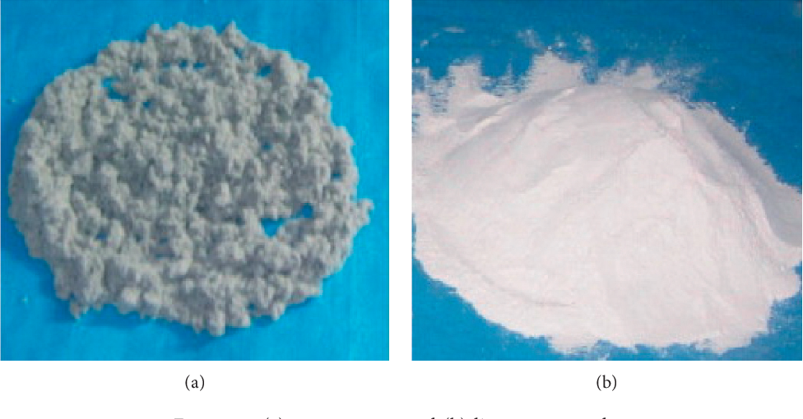

Cotton waste limestone powder

**2.LITERATURE REVIEW**

**Paper1: Ines Labaied, Omar Douzane, Marzouk Lajili and Geoffrey Promis,**

**21 October 2022**

**MAIN FINDINGS**

**Fired Brick:**

*•* Shrinkage varied from 0.3% for pure clay to 0.6% and 0.9% when 1% and 10% of POFA were used, respectively. Nevertheless, the linear shrinkage increases progressively with increasing percentages of ash addition for all used ashes.

*•* It was discovered that the loss on ignition of lignocellulosic ash bricks increases with increasing the percentage of added ash in the mixture. This finding suggested that, if the sintering process is not carried out at sufficient heating rates, using these ashes to create fired bricks could result in a significant volume reduction with deformation or breakage of the bricks.

*•* Except for the addition of sugarcane bagasse ash (SBA), which has a high-water absorption rate (>22%), all fired bricks constructed from lignocellulosic biomass ashes exhibited severe to moderate resistance to weathering.

*•* The brick density decreases as the reinforcement rate increases. The chemical composition as well as the type of combustion of these ashes largely affect the

density of the final products.

*•* The thermal properties of the bricks were limited to the calculation of thermal conductivity. The thermal conductivity of bricks made with lignocellulosic biomass ash is significantly influenced by the brick density. More thermally insulating bricks are produced when the density is lower.

*•* A reduction of compressive strength occurred when the ash content in the clay matrix increased.

**Unfired Brick:**

*•* The compressive strengths of all unfired clay bricks stabilized by the addition of cement/lime with lignocellulosic ash percentages, are higher than those of class 30 block.

*•* The use of activation solutions favors the densification of the unfired bricks, which increases the thermal conductivity values.

*•* It was determined that mechanical and physical tests produced the best results for the 20% distilled water bricks.

*•* A significant improvement in compressive strength has been noted between geopolymer bricks prepared by applying compaction pressure during the molding process and those prepared without any compression during the molding process.

*•* The water absorption was higher at a cement content of 10% than at a cement content of 4% which proves that the addition of SBA is more effective at lower cement contents.

**ADVANTAGES**

It is suggested that the number of lignocellulosic ashes added to the clay matrix must not exceed 10% in order to achieve a compromise between mechanical and thermal performances. Furthermore, the use of wastewater from oil mills rich in melting oxides and silica with a mixture of lignocellulosic biomass ashes and small amounts of agro-food waste from the agri-food industry, such as the residues of olive by-products could be an interesting investigation. This type of substrate when added to the clay matrix, could improve the sintering and the porosity which affects positively the thermal properties of the bricks without degrading too much the mechanical properties.The stabilization of bricks by chemical binders using alkaline activation fits perfectly in the sustainable development context where a high volume of waste such as lignocellulosic biomass ashes could be reused and valorized in the clay matrix with a carbon footprint considered as zero. The stabilization of unfired bricks by chemical binders developed by alkaline activation to produce a polymerization reaction, responds perfectly to the recent challenges inherent to sustainable production.

**DRAWBACKS**

Despite the numerous benefits of using lignocellulosic biomass ash in the production

of clay bricks, the firing process in conventional kilns continues to be energy-intensive and polluting. A strength of 59.2 MPa was determined for geopolymer bricks prepared entirely from chamotte, a compression of 50 MPa was used to mold specimens of an internal dimension of 6 *×* 3 cm. However, to achieve the 50 MPa for bricks with actual dimensions of 22 *×* 10.5 *×* 5 cm3 , 1155 KN of force must be applied, which is completely unsuitable for use on an industrial scale. The commercialization of the geopolymer bricks may also be constrained by the high cost and negative environmental impact associated with the use of alkaline activators in various research projects.

**Paper2: Amaliyah Rohsari Indah Utami, Putri Dwi Haryati, Mohammad Fakhrurrozie Sulaeman, 02 March 2021**

**MAIN FINDINGS**

*•* The compositional results showed that the mixture of clay/corn waste did not contain harmful salts such as Magnesium Sulfate (MgSO4), Sodium Sulfate (Na2SO4), and Potassium Sulfate (K2SO4). Therefore, a mixture of clay/corn waste as biocomposite brick have good properties as brick building materials.

*•* The tolerance of porosity in bricks mixed with corn lignocellulosic waste is good which is not more than 20%. The incorporation of 4 wt.% of sun flower seed cake, with the lowest grinding, leading to an increase of 23% of porosity and decreases of 17% of the bending strength and 61% of the thermal conductivity.

*•* The silica and aluminum greatly affected the compressive strength of a material. In addition, the carbon contained serves to strengthen material and is resistant to water or hydrophobicity.

*•* The density produced according to SNI 15-2094-2000 standards is not less than 20 grams / cm3 . Therefore, biocomposite bricks meet predetermined standards. Bricks with a mixture of corn pulp have high carbon content. This is one factor that causes the density results are not too large but still in accordance with the standard.

*•* In addition, the treatment in making samples such as temperature also affects the quality of the compressive strength of a material. The compound content that most influenced the hardness and compressive strength of the material was the biocomposite brick study with the addition of corn waste to obtain a yield of 6.81 MPa. Meanwhile, clay without mixture as the control variable of brick was 4.15 MPa.

**ADVANTAGES**

Technological tests realized on the developed fired clay bricks showed the impact of the additives upon the properties of the material: an increase of the porosity, water absorption and thermal insulation was observed. The reuse of these wastes clearly presents several advantages whether it is on an technological aspect or on an economical point of view: it leads for example to a reduction of the costs due to the use of wastes by substitution of the clay matter and a reduction of transportation costs due to the production of lighter products.

**DRAWBACKS**

Technological tests realized on the developed fired clay bricks showed the impact of the additives upon the properties of the material: a decrease of the bulk density and the bending strength. Compromises have thus to be found in order to produce more efficient products with high thermal and mechanical performances.Regarding thermal performance, the thermal conductivity was reduced for all samples, with the addition of vegetable materials. As a regard to the mechanical results, a decrease in the bending stress can be observed for all samples.

**Paper3: Mohamad Nidzam Rahmat , Norsalisma Ismail, John Mungai Kinuthia,**

**27 August 2016**

**MAIN FINDINGS**

*•* Lime activated GGBS improves the properties of clay soils during the stabilisation process. The UCS test results of unfired bricks stabilised with lime and PC system at 10% stabiliser dosage show that the strength development increased progressively from 7 days to 28 days curing period for both systems, Lime and PC only and blended Lime:GGBS (30:70) and PC:GGBS (40:70) blending ratio.

*•* The percentage water absorption for LOC-PFA unfired bricks stabilised with Lime and PC system at 10% stabiliser dosage show a similar pattern of water absorption capacity, higher initial water absorption reduces with increases in soaking period. For all mixes, the water absorption rate was higher during the first 3–7 days of soaking and at later ages lower and fairly stable.

*•* The results for thermal conductivity of unfired LOC-PFA bricks stabilised with Lime and PC system, with two specimens were tested for each stabiliser and the mean values were reported. It is reported that replacing cement with fly ash and slag decreased the thermal conductivity. Increased in temperature also indicated an increase in the thermal conductivity.

*•* The overall freezing-thawing results for unfired LOC-PFA bricks stabilized with Lime based system. As the freezing and thawing cycle increased, the weight losses of the bricks also increased. The weight losses are within the range of 0.80–2.58% at the end of 30th cycle. Test specimen stabilised with Lime only showed higher percentage weight losses when compared to blended Lime-GGBS (30:70) stabilizer.

**ADVANTAGES**

It indicates that GGBS has a high potential as partial replacement material for traditional stabilisers.The additional of the Lime-and-PC-based stabiliser systems to LOC-PFA has enhanced many of the engineering properties of the soil, producing an improved building material. The unfired clay technology using GGBS as the main stabilising agent for production of building bricks helps reduce the energy costs of the firing process, reduce environment damage associated with the manufacturing of traditional stabilisers, and thus, reduce greenhouse gas emissions that contribute to global warming. The practical implications of this experimental programmed is that unfired bricks can be used for community based housing development and can be applied to internal wall construction, with the overall target of improving the quality, cost effectiveness and most importantly, it can be considered as part of sustainable building materials. With less energy output and less CO2 emissions during the production stage, this type of unfired brick can be classified as a green building material.

**DRAWBACKS**

The current work has indicated that there is an increasing number of potential non-traditional sustainable soil stabilising agents, with same techniques applied in this research, other stabilising agents can be used as part of the main target materials and as stabilisers with appropriate ratios for the better strength and durability achievement. A wider range of analytical studies on the cured stabilised samples is advocated, especially on the microstructure of the harden mixture, such as X-ray Diffraction (XRD) and Nuclear Magnetic Resonance (NMR), with a view to further characterizing and understanding the nature of the cementitious materials.

**3.EXPERIMENTAL STUDIES**

**Fired Clay Bricks Reinforced by Lignocellulosic Biomass Ash**

To study the effect of ashes on clay bricks, Table 1 summarizes several works carried

out and various parameters considered during clay brick preparation. Ashes from olive wastes were the most commonly used, especially in the Mediterranean region where this ash type is produced in huge quantities.When used olive bottom ash (OPBA) from the combustion of Spanish olive pomace in a steam boiler mixed with an equal share of three types of clay: yellow, red, and black raw clay, respectively. The replacement rate was ranging from 10% to 50%. As shown in Table 2, the olive bottom ash (OPBA) was formed by 12.5% SiO2 and Al2O3 which represent the skeleton components of bricks, 53.1% of melting oxides (mainly CaO, Na2O, K2O, and MgO), and gaseous components formed by 1.6% FeO3, 42.28% CaCO3 and 13.5% of organic matter. The latter is responsible for the generation of gases and swelling of ceramic bodies during sintering at high temperatures. This study proves the feasibility of using OPBA up to 20% as a partial substitute for clay to produce good quality of fired bricks. However, only 10% weight of OPBA displays the optimum value that confirms the good balance provided by both melting capacity and porogen capacity. These ashes came from the same plant and same source as those used in the earlier study. 1500 tons of bottom ash and 5400 tons of fly ash were produced annually at that plant. These ashes were mainly composed of K2O, silica, and auxiliary flux oxides (CaO, MgO) (Table 2). Based on experimental results, it was shown that when using fly ash up to 25% by weight in the clay brick, the final product was useful in the manufacture of ceramic bricks for building materials. But, for obtaining bricks with superior physical and mechanical properties, a limitation of 5% by weight of CVLL should be considered.

#### 

#### 

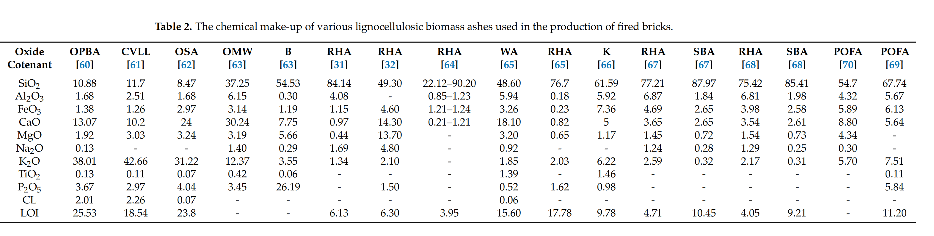

**Unfired Clay Bricks Reinforced by Lignocellulosic Biomass Ash**

In Table3, investigated the mechanical properties of raw earth blocks stabilized with 4% and 10% ordinary Portland cement (OPC) and altered with 4%, 6%, and 8% sugarcane bagasse ash (SBA). Except for the addition of 4% SBA, where a slight loss of strength of 3.86% could be felt, earth blocks stabilized with 4% cement show a steady increase in strength with increasing SBA content. However, a gain of 2.32% and 13.9% was observed when adding 6% and 8% SBA (2.56 MPa and 2.95 MPa, compared to 2.59 MPa of the control block). For 10% cement stabilized blocks, incremental additions of 4%, 6%, and 8% SBA led to steady increases in compressive strength of 1.48%, 2.77%, and 7.93%. Adding SBA at a lower cement content led to a greater increase in compressive strength. Adding 8% SBA was the only way to achieve a compressive strength that complied with standards for the earth block stabilized with 4% cement. However, the compressive strength was attained for blocks stabilized with 10% cement without the addition of SBA. For water absorption, the addition of SBA to cement yielded a slight increase in the water absorption of the blocks. This water absorption was higher at a cement content of 10% than at a cement content of 4% which proves that the addition of SBA is more effective at lower cement contents. It also investigated the stabilization of residual soils using 4% to 8% cement and rice husk ash (RHA) at percentages ranging from 5% to 25% by step of 5%. When comparing the compressive strength results of stabilization of earthen blocks by adding (RHA) to cement compared to cement alone, it was seen an increase in mechanical strength. The use of 4% cement alone for stabilizing the earthen blocks leads to a compressive strength of 0.882 MPa. However, the addition of 5%, 10%, 15%, 20% and 25% RHA generates a compressive strength of 1.654, 3.154, 3.309, 3.011 and 1.187 MPa, respectively. As a result, the formula with 15% to 20% of RHA increases the compressive strength significantly when compared to the cement alone, while above this value range, the resistance significantly decreases.

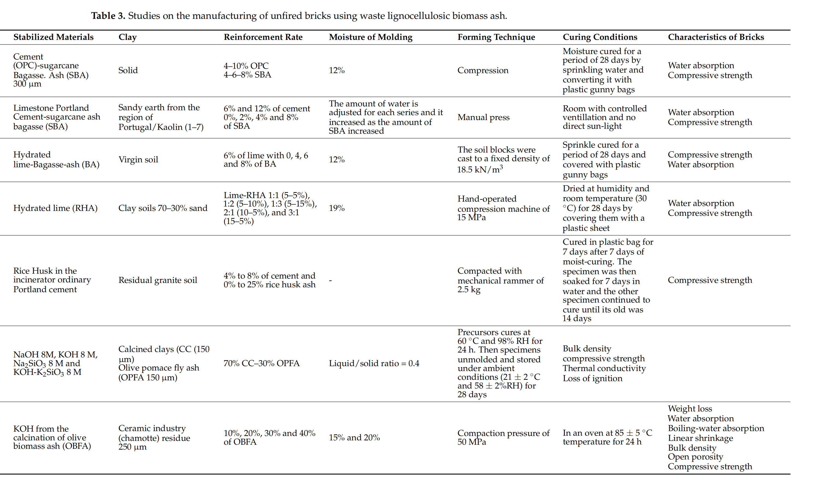

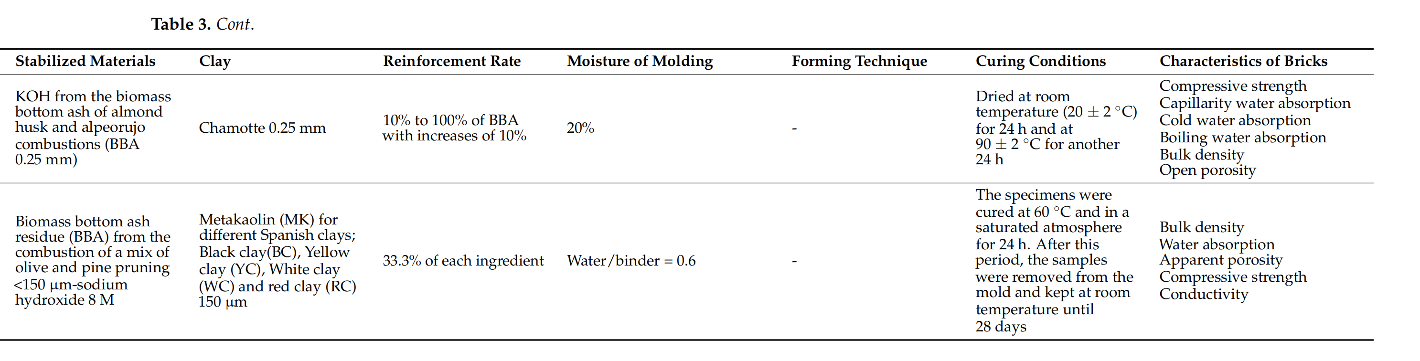

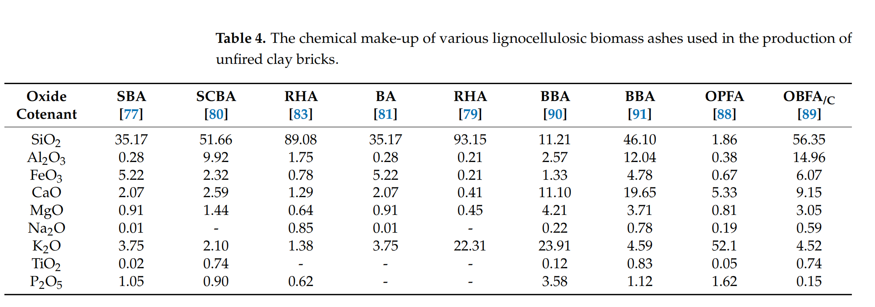

**4.METHODOLOGY**

Depending on the origin of lignocellulosic biomass and the used equipment, the rate of ashes and their chemical composition varies. There are two main types of ash: bottom ash and fly ash. Bottom ash or under-furnace ash is issued from grates and circulatinglfluidized beds. However, fly ash is composed of coarse fly ash from the dust collector (multi-cyclone) after the treatment of fumes and fine ash from a bag filter or electro filter. Fly and bottom ashes are mainly composed of silica (SiO2), phosphates (P-P2O5), oxides, hydroxides, carbonates, silicates, sulfates, calcium, potassium, sodium, magnesium, organic matter, total unburned organic carbon and traces of metals such as Cr, Ni, Zn, As, Se, Mo, Cd, Pb, Hg, respectively. In order to avoid the effects of these ashes on the environment, they must be interred in cells designated for hazardous or non-hazardous wastes based on their rates. Since this method is very expensive, several alternatives are investigated such as chemical and thermal stabilization. The chemical stabilization could be produced either by the pozzolanic reaction. This process leads to the precipitation of a variety of hydrated calcium silico-aluminates as binders which become promising and sustainable alternatives in the manufacture of unfired bricks. The following step is the thermal stabilization which consists of mixing these ashes with clay and heating the mixture in high-temperature furnaces.

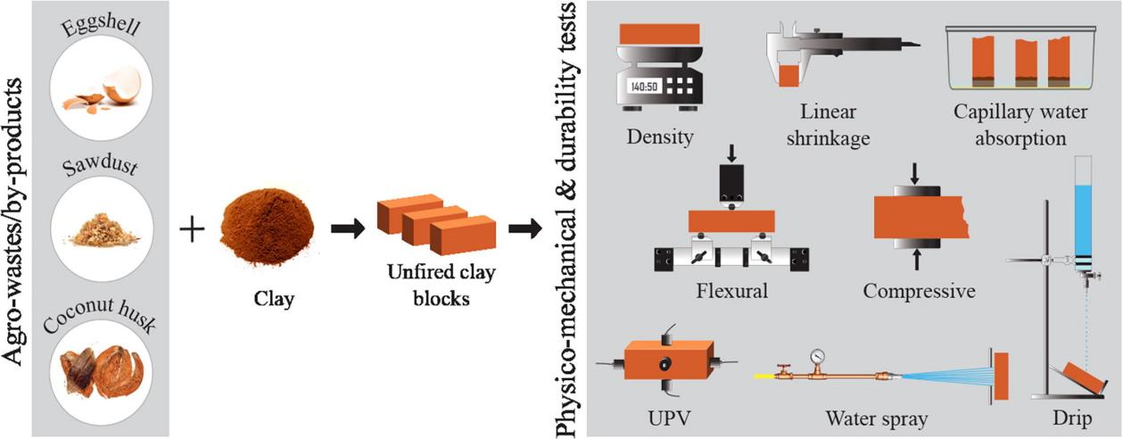

**4.1 Unconfined Compressive Strength(UCS)**

The project is aimed at the building industry where higher strength values are needed for bricks and blocks. A brick size of 140 mm width x 295 mm length x 55 mm thick with a density of 1540 kg/m3 were prepared using target materials at 1.2 OMC with the formulation T + ST + W (T + ST) = 3500 g., where T = Target Soil + Siliceous Additive (PFA), s = Stabiliser dosage (%) and W = Water (%). The OMC of 29% was pre-determined from proctor compaction test in accordance with BS 1377-2:1990. Mix design composition was as shown in Table 2. The materials were mixed thoroughly after adding the pre-calculated amount of water. Mixing of the material was achieved by using Model SE-401 Hobart 40 Qt mixer. Bricks weighing 3500 g were prepared for all mix proportions. A manual steel mould fitted with a lid and handle was used to compact the material in bricks forms. After compaction, the bricks were extruded from the mould, trimmed and wrapped with cling film to prevent rapid moisture loss, and cured at a room temperature of ±20 C and at 100% relative humidity. The UCS test carried out as described in BS 1377-7:1990 (soil for engineering purpose) using a Hounifield testing machine capable of loading up to 100 kN, on the 55 mmx285 mm side surface of the bricks at a compression rate of 0.15 kN/min. A self levelling device was used to ensure uniaxial load application.

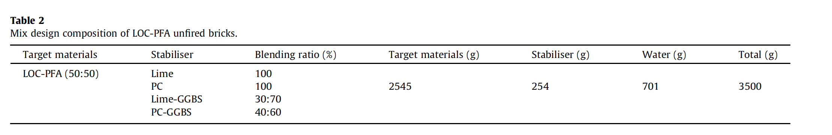

**4.2 Water Absorption Test**

Water absorption tests for laboratory unfired bricks specimens were carried out in accordance with BS EN 771-1:2003 (Specification for masonry units – Part 1: Clay masonry units). Two bricks per mix composition were subjected to water absorption test, and the mean% water absorption determined.

**4.3 Thermal Conductivity Test**

It was determined in compliance with BS EN 1745:2002 (Masonry and masonry products – Methods for determining design thermal values). Thermal conductivity (k) used to assess the ability of material to transfer heat by conduction. It also refers to the heat flow rate (U), and represents thermal energy transfer in unit time and is measured in Watts (joules/s). Test specimen of dimension 140 mm X 147 mm X 40 mm thick with a density of 1540 kg/m3 was prepared.

**4.4 Freeze and Thaw Tests**

The freeze-thaw testing was performed according to BS 5628- 3:2005 (Code of practice for the use of masonry: Materials and components, design and workmanship) and to DD CEN/TS 12390- 9:2006 (Testing hardened concrete. Freeze-thaw resistance scaling). The test was performed in a Prior Clave LCH/600/25 model

0.7 m3 volume capacity environmental chamber. The apparatus consisted of refrigerating and heating unit, with continuous freeze thaw cycles at chamber temperatures in the range of ±20 C . Both dry and wet freezing-thawing test were adopted for this study, modified from the above concrete-based standards in order to determine freeze and thaw properties of the target materials (unfired LOC-PFA bricks).

**4.5 Brick Sample Production**

*Mix preparation*: for this specific study, the required amount of raw materials and additives was measured by using a 24 cm × 12 cm × 6 cm volume box with different ratios. The amounts of materials were prepared according to ASTM mixing that means 1 : 2 : 3 and 1 : 2 : 2, where mix ratio 1 : 2 : 3 means one part cement to two parts sand and three parts gravel. In the beginning, the aforementioned raw materials were mixed with water and homogenized with each other in proportion before sample brick preparation. The raw materials have been mixed with enough amount of water to obtain homogeneous and smooth mixture for molding operation. In the mixing process of samples, the clay was mixed till it is observed that CW is uniformly scattered within the mixes. In order to obtain more homogeneous mixes, the water was sprayed by using a water pump onto the mixes while the mixing was carried out. If mixing was performed effectively, it reduces cracking during drying. Afterward, the fresh mixes were fed into the wood molds.

**4.6 Brick Sample Characterization**

*Compressive strength:* the dry compressive strength of brick samples was determined by using the servocontrolled compression test machine with a maximum capacity of 800 KN. The compression load was applied onto the face of the sample having the dimensions of 240 mm × 60 mm. The compressive strength was determined by dividing the maximum load with the applied load area of the brick samples. Also, compressive strength was calculated using Stress = Force/Area.

*Water absorbency*: by taking one sample from each mixed ratio, twelve brick samples with the dimension of 24 cm × 12 cm × 6 cm were used for the water absorption test. First, the samples were placed on the oven dry at 105°C in order to remove the existing moisture on the brick till no mass variation is observed. The oven dried bricks were immersed into the water curing tank (water container tank) for 24 hours. Then, the cured samples were wiped using dry cloth to remove the excess water, and the weight of brick after wetting was taken. The water content of samples in percent was calculated using Water absorption % = W2 – (W1/W2) × 100,

where W1 is dry weight of the brick and W2 is weight of the brick after wetting.

*Mass of the brick sample:*  The brick samples were cooled at room temperature, and their unit weights were obtained by dividing the mass of the bricks by their overall volume. In this calculation, the unit weight of the brick is directly proportional to the mass of the brick, but inversely proportional to volume. Ten samples were tested for the unit weight test by taking one sample from each mix ratio. 'e samples have the same volume 24 cm × 12 cm × 6 cm and different mass depending on their mix percentages.

**5.ANLAYSIS AND FINDINGS**

**5.1 Effect on Physical Properties**

**5.1.1 Linear Shrinkage**

Linear shrinkage is a key parameter for fired bricks. It describes the contraction or expansion behavior of bricks during heat treatment. It can be determined by measuring the length of the sample either before and after drying or before and after firing. It is to be highlighted that shrinkage depends strongly on the nature and chemical composition of the biomass ash used and mainly on the content of melting oxides and continuous gaseous components in the ash, so that no real comparison could be made between the different types of ash. However, it is recommended that the curing shrinkage should be between 2.5% and 4% to maintain good mechanical performance. Indeed, excessive shrinkage causes stresses and breaks of the prepared material, despite that all samples were manufactured with different types of lignocellulosic ashes respecting the standard conditions.

**5.1.2 Loss of Ignition**

Loss of ignition is the loss of mass as a result of the bricks firing. It was determined by measuring the loss of mass of the sample between the drying and firing stages.The findings suggested that, if the sintering process is not carried out at sufficient heating rates, using these ashes to create fired bricks could result in a significant volume reduction with deformation or breakage of the bricks. Thus, to maintain good performance, the loss on ignition should remain below 15%.

**5.1.3 Water Absorption**

The compressive strength and durability of the elaborated samples are greatly impacted by water absorption, making it a crucial bricks parameter. For lignocellulosic biomass ash bricks, the water absorption depends mainly on the percentages of the added ashes. All of the aforementioned research projects showed that water absorption rises as the proportion of biomass ashes used in the clay matrix increases. The hydrophilic nature of biomass ash accounts for the increased ability of the hardened matrix to absorb water. Additionally, the addition of the continuous organic matter in the lignocellulosic ash acts as a porogen material, leaving pores and voids during the curing process so that the open porosity increases the water absorption. For bricks with severe weathering resistance, the water absorption should not be higher than 17%. For bricks, with moderate weathering resistance the water absorption should not be higher than 22% and no limit is set for bricks with negligible weathering.

**5.1.4 Density**

Density is defined as the ratio of the weight of the dry brick to the volume, which quantifies the amount of material present in the volume. All of the studies showed that adding lignocellulosic biomass ash to the clay matrix decreased the bricks’ bulk density, which is strongly advised for future bricks . Since the bricks of today are too heavy and tightly packed, research is being carried out to create new products that are lightweight and manageable during construction. Using waste lignocellulosic ash as a porogen agent and adding it to the mixture is an intriguing way to achieve the desired effect.

**5.2 Effect on Thermal Properties**

Many factors such as mineralogical composition, type of porosity (open or closed porosity), pore size, measurement method, and density are important factors that govern thermal conductivity. The thermal conductivity of bricks made with lignocellulosic biomass ash is significantly influenced by the brick density. More thermally insulating bricks are produced when the density is lower. It can be seen that adding 6.5% of olive mill waste (OMW) produced the lowest density (1110 kg/m3 ) and lowest thermal conductivity (0.143 W m*−*1 k*−*1 ), whereas adding 10% of wood stone ash (WA) produced the highest density (1800 kg/m3 ) and highest thermal conductivity value (1 W m*−*1 k*−*1 ). This might be accounted for by the fact that a low density permits a higher percentage of air volume to fill the voids. As a result, by serving as effective insulator, the greater volume of air in the pores lowers the solid matrix’s overall thermal conductivity.

**5.3 Effect on Mechanical Properties**

The most important property of construction materials is compressive strength.It can be observed that a reduction of compressive strength occurred when the ash content in the clay matrix increased. This result is coherent with bulk density and water absorption behavior. Bricks with higher porosity, lower compressive strength, and higher water absorption were produced at higher doses of lignocellulosic biomass ash. Due to their irregular shape and microscopic flaws, open pores can concentrate pressure and reduce the compressive strength of bricks.It was observed that the higher the value of the forming pressure, the more improvement of the mechanical properties.While finer particles create denser composites that offer better sintering and greater strength, larger particles restrict compaction within the bricks, leading to the formation of significant amounts of voids that degrade mechanical strength. A variety of factors, including the source of the ashes, their chemical makeup, the type of clay used, the size of the particles, etc., determine the mechanical strength of the bricks.

**5.4 Effect of Cotton microdust**

**5.4.1 Effect on strength**

The observations during the tests show that the effect of 100% cotton waste does not exhibit a sudden brittle fracture even beyond the failure loads and indicates high energy absorption capacity by allowing lower labouring cost. From this, we can conclude that when the amount of cotton waste increases, the compressive strength of that brick also increases and vice versa. Figure indicates that as the cotton waste increases from 0% to 20% there is a sharp increase in compressive strength properties of the produced brick sample.

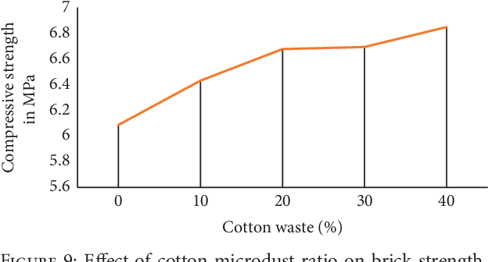

**5.4.2 Effect on Water Absorbency**

The water absorption of the blank sample (100 % cotton dust) is extremely higher. This is an expected result owing to the water absorption nature of cotton waste. Also, in general, as the cotton dust increases, the water absorption also increases. The water absorption of any bricks shall not be more than 20%. In the current study, the water absorption properties of the bricks lie in the range between 5–12 % in all mix ratios. From the test result values and the norms for constriction bricks for the water absorption value, the produced bricks can categorized as first-grade bricks.

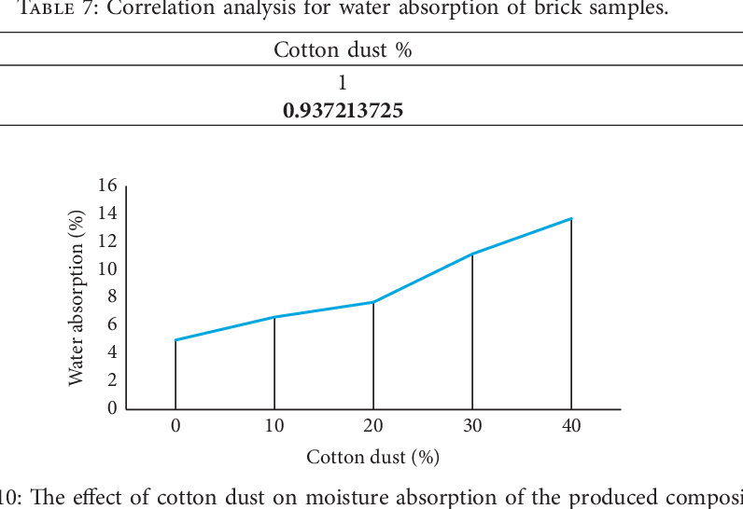

**5.4.3 Effect on Mass of the sample**

When the mass of the blank sample is compared with the other mix ratios, the sample that contains more cotton waste is lighter. so, as the percent of cotton dust increases, the mass of the brick also decreases.

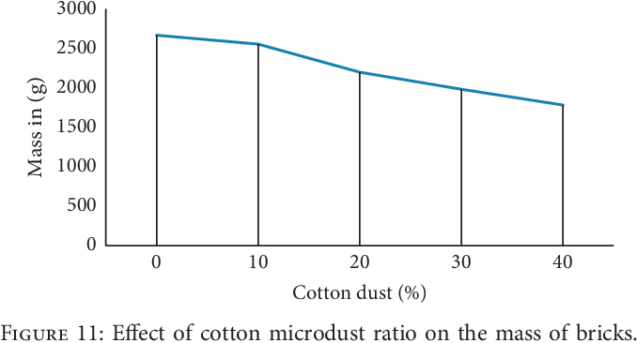

1. **ADVANTAGES AND DRAWBACKS**

**6.1 Fired Brick Using Lignocellulosic Biomass Ash**

The benefits of biomass ash addition in bricks are the conservation of natural resources,solving disposal problems and protecting the environment. Lignocellulosic biomass ash can be used as a filler and additive material for the clay in fired brick production, and this mixture has a good potential for reusing the waste.It is suggested that the number of lignocellulosic ashes added to the clay matrix must not exceed 10% in order to achieve a compromise between mechanical and thermal performances. Furthermore, the use of wastewater from oil mills rich in melting oxides and silica with a mixture of lignocellulosic biomass ashes and small amounts of agro-food waste from the agri-food industry, such as the residues of olive by-products could be an interesting investigation. This type of substrate when added to the clay matrix, could improve the sintering and the porosity which affects positively the thermal properties of the bricks without degrading too much the mechanical properties. Despite the numerous benefits of using lignocellulosic biomass ash in the production of clay bricks, the firing process in conventional kilns continues to be energy-intensive and polluting.

**6.2 Unfired Brick Using Lignocellulosic Biomass Ash**

In comparison to fired bricks, stabilized unfired bricks permits the incorporation of higher levels of lignocellulosic biomass ash waste than fired bricks. The majority of unfired bricks are stabilized by the use of cementitious binders (lime/cement), but the high carbon footprint associated with the use of these binders is considered the main drawback. Geopolymer bricks were recently developed in the ceramic industry and were considered viable alternatives to cement-lime stabilized bricks. The stabilization of bricks by chemical binders using alkaline activation fits perfectly in the sustainable development context where a high volume of waste such as lignocellulosic biomass ashes could be reused and valorized in the clay matrix with a carbon footprint considered as zero. Indeed, as geopolymers have molecular structures close to zeolite, they can also immobilize toxic wastes or heavy metals contained in these ashes, thus decreasing the cost and the problem of burying this type of material. Nevertheless, different drawbacks limit the use of these geopolymer bricks on an industrial scale. Alkaline activation of clay soils at low temperatures is being researched more and more as a method of soil stabilization. Indeed, the use of low-quality raw clays other than kaolin and without thermal pretreatments, such as Montmorillonite, Illite, etc. would be a solution to reduce greenhouse gas emissions, manufacturing costs, and excessive use of kaolin by valorizing widely available natural clays at low-cost. This substitution would allow an energetic gain by overcoming the step of thermal treatment of clay. However, the understanding of the reactivity of soils using alkali activation stabilization is complex because of the different parameters that can influence their reactivity such as the clay composition of the soil, and the particle sizes, . . . In this context, a better understanding of alkaline activation of clay minerals without prior calcination is needed. The commercialization of these geopolymer bricks may also be constrained by the high cost and negative environmental impact associated with the use of alkaline activators in various research projects. The use of mixed binders (chemical and cementitious) seems to be appropriate to overcome the cost considerations for chemical binders.These geopolymer bricks based on lignocellulosic ashes could compete with fired bricks which are preferred by their high mechanical resistance.

**7.CONCLUSION**

This study focuses on the use of lignocellulosic ash as a partial replacement for clay in the manufacture of fired and unfired clay bricks and their industrial integration. Indeed, the use of lignocellulosic ash in the manufacture of bricks is a promising way to decrease the need for non-renewable clay, as well as to reduce the environmental risks and high costs associated with the landfilling of this ash. Several conclusions can be drawn:

*•* Ashes from lignocellulosic biomass are favored by high concentrations of melting oxides, which enable the reduction of the firing temperature of the fired clay bricks. However, a sizable amount of their use causes the bricks’ compressive strength to decline. Considering the various results of the research made on fired clay bricks elaborated by lignocellulosic biomass ashes, and to make a compromise between thermal and mechanical properties, it is advised that the rate of reinforcement within the clay matrix be lower than 10% for the ashes-rich in melting oxides and lower than 4% for the ashes rich in amorphous silica and gaseous materials to ensure a compromise between physical, thermal, and mechanical properties.

*•* To decrease the energy required to fire bricks in conventional kilns, numerous studies have concentrated on the development of unfired bricks stabilized by lignocellulosic biomass ash and cementitious binders (lime/cement). The combination of cement and lignocellulosic ash offers a promising way to both cut down on cement usage and waste production. The addition of lignocellulosic ash at a lower cement content results in the gain of higher compressive strength. With cement percentages below 10%, this gain was no longer significant.

*•*  The use of lignocellulosic biomass ash rich in potassium oxide is a promising and affordable solution to reduce the high cost of chemical binders in the manufacture of geopolymer bricks. It has interesting mechanical and physical properties similar to those desired for fired bricks, which encourages brick factories that are a part of the sustainable development framework to carry out this research from the laboratory scale to the industrial scale.

#### The cotton has an effect in order to increase the water absorption of the brick, while up to 40 % of cotton waste with soil is good. As the cotton waste percentage increases, the water absorption and compressive strength of the brick also increase, but the mass of the brick decreases. The microdusts are very fine and denser, so they increase the cohesiveness of the clay for brick. 'e bricks manufactured from soil and cotton waste have good results because they burn in order to increase their strengths. Therefore, the microdusts of cotton mixes with soil are preferable to manufacture brick. It results in a sturdy lighterweight composite having potential to be used for walls, as a wooden board substitute, economical alternative to the concrete blocks, and sound barrier panels.

#### REFERENCES

1. Labaied, I.; Douzane, O.; Lajili, M.; Promis, G. Bricks Using Clay Mixed with Powder and Ashes from Lignocellulosic Biomass: A Review. *Appl. Sci.* **2022**, *12*, 10669.

https://doi.org/10.3390/app122010669.

1. AIP Conference Proceedings **2320**, 050027 (2021); “Effect of lignocellulosic corn waste addition on the porosity, density, and compressive strength of fired clay brick”

https://doi.org/10.1063/5.0037448 Published Online: 02 March **2021**.

1. Bories, Cécile and Aouba, Laila and Vedrenne, Emeline and Vilarem, Gérard *Fired clay bricks using agricultural biomass wastes: Study and characterization.* (2015) Construction and Building Materials, 91. 158-163. ISSN 0950-0618.
2. Mohamad Nidzam Rahmat, Norsalisma Ismail, John Mungai Kinuthia Strength and environmental evaluation of stabilised Clay-PFA eco-friendly bricks, 27 August (2016).
3. Muñoz Velasco, P.; Morales Ortíz, M.P.; Mendívil Giró, M.A.; Muñoz Velasco, L. Fired clay bricks manufactured by adding wastes as sustainable construction material—A review. *Constr. Build. Mater.* **2014**, *63*, 97–107.
4. Gupta, V.; Chai, H.K.; Lu, Y.; Chaudhary, S. A state of the art review to enhance the industrial scale waste utilization in sustainable unfired bricks. *Constr. Build. Mater.* **2020**, *254*, 119220.
5. Srisuwan, A.; Phonphuak, N. Physical property and compressive strength of fired clay bricks incorporated with paper waste. *J. Met. Mater. Miner.* **2020**, *30*, 103–108.
6. Osofero, A.I.; Momoh, E.; Salih, M.; Koliopoulos, T. Innovative Use of Agricultural Wastes for Eco-Friendly Construction. *Emerg. Environ. Technol. Health Prot* **2018**, *1*, 96–115.